# Community climate action logo

# Getting around Bristol: A guide for Disabled people

## June 2025

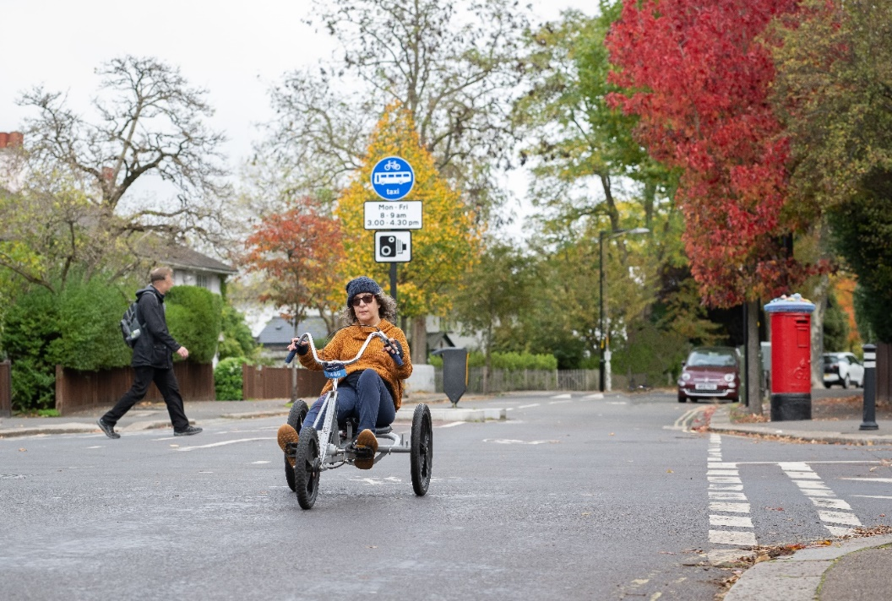

Photo credit: Wheels for Wellbeing

Image description: A woman wearing a beanie hat, sunglasses, an orange jumper and jeans, rides a handcycle down a residential street. In the background there are red and orange autumnal trees, a red post box and a man crossing the road.

Contents

Introduction 3

Who this guide is for 3

Using this guide 3

The bigger picture 3

Plan your journey 5

Journey planner websites 5

Journey planner apps 5

WEST link bus service 6

Try a new way to travel 7

Try something new for free 7

Cycling 7

Get help with the cost of your journey 8

Accessibility on your journey 10

Accessible train stations 10

Passenger assistance on the train 11

Report a problem on your journey 12

Buses 12

Trains 12

Taxis 12

Hate crime 13

Blocked pavements 13

Where to find further information and support 15

National organisations 15

Local organisations 15

Jargon buster 17

## Introduction

### Who this guide is for

This guide is for Disabled people who are travelling around Bristol. It tells you where you can find out more information about planning your journey, trying a new way to travel, help with the cost of your journey, help on your journey, and reporting a problem on your journey. This guide will not contain all the information you might need, but we hope it will be a useful starting point.

The information in this guide is mostly focused on **public transport** and **active travel**, but we know some Disabled people will need, or prefer, to drive to get around. Information on driving routes and parking can be found on [TravelWest](https://journeyplanner.travelwest.info/directions) and [the Bristol City Council website](https://www.bristol.gov.uk/residents/parking).

### Using this guide

At the end of this guide is a **jargon buster**. A jargon buster is a list that explains the words that not everyone will understand. Words included on the jargon buster are in bold.

This guide was created in response to requests for information that could be provided to Disabled people travelling to events across the city. Therefore, we are happy for organisations to use and share this guide. However, we cannot be sure the information will remain accurate and up-to-date and so if you are sharing it, we recommend checking links are live and information is in date.

### The bigger picture

This guide provides information on getting around Bristol now. However, we know that there are barriers for Disabled people travelling around the city which stops Disabled people from doing all the things they need, and want, to do. The information in this guide does not solve these barriers but there are a number of individuals and organisations working hard to make transport more accessible for Disabled people in Bristol, and across the UK.

In 2024 the Bristol Climate and Nature Partnership **published** (made available to the public) an [Inclusive Transport **Vision**](https://bristolclimatenature.org/projects/community-climate-action/transport/)**.** This describes what transport could look like in Bristol if everyone’s needs were met. It explains how more **accessible** and **sustainable** transport can help improve people’s everyday lives.

We know that the barriers to getting around Bristol as a Disabled person, and having to fight for your access, is very tiring and frustrating. For further help and support, there is a list of organisations at the end of this guide.

## Plan your journey

### Journey planner websites

Travel West have a **journey planner** on their website where you can find directions to places within the West of England via different types of transport, including by car, bus, train, walking and cycling. You can also use the map to find **car clubs**, **electric car charging points**, train stations, and taxi ranks in the West of England. [Visit the Travel West website to use the journey planner.](https://journeyplanner.travelwest.info/directions)

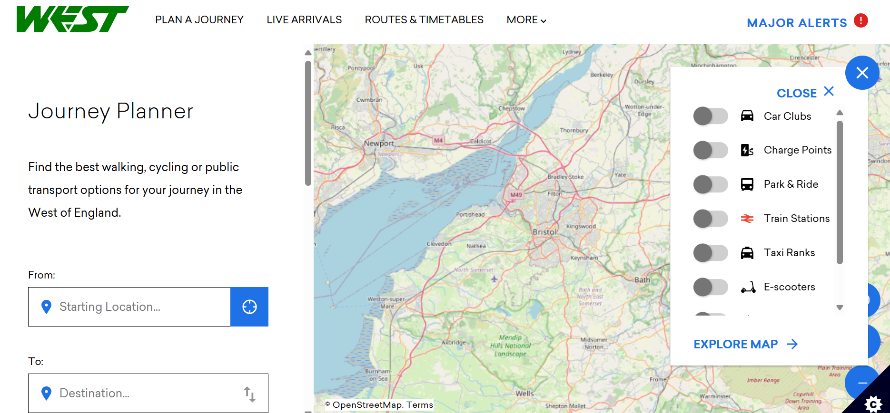

Image credit: Travel West website

Image description: The webpage for Travel West's Journey Planner features a map of the West of England and a search bar where you can find directions to your destination.

### Journey planner apps

You can also use an app on your phone for planning your journey. Each app has different **accessibility features** so make sure you find one that suits your needs. Some examples of apps include:

* [First Bus](https://www.firstbus.co.uk/buy-tickets/ways-pay/first-bus-app) - for bus routes, live bus times and First Bus tickets,
* [Moovit](https://moovitapp.com/) – this app can be used with voiceover and talkback, and you can make the text bigger,
* [City Mapper](https://citymapper.com/) – provides step free and wheelchair accessible **routes** in cities,
* [Go Jauntly](https://www.gojauntly.com/download-1) – find walking **routes**.

### WESTLink bus service

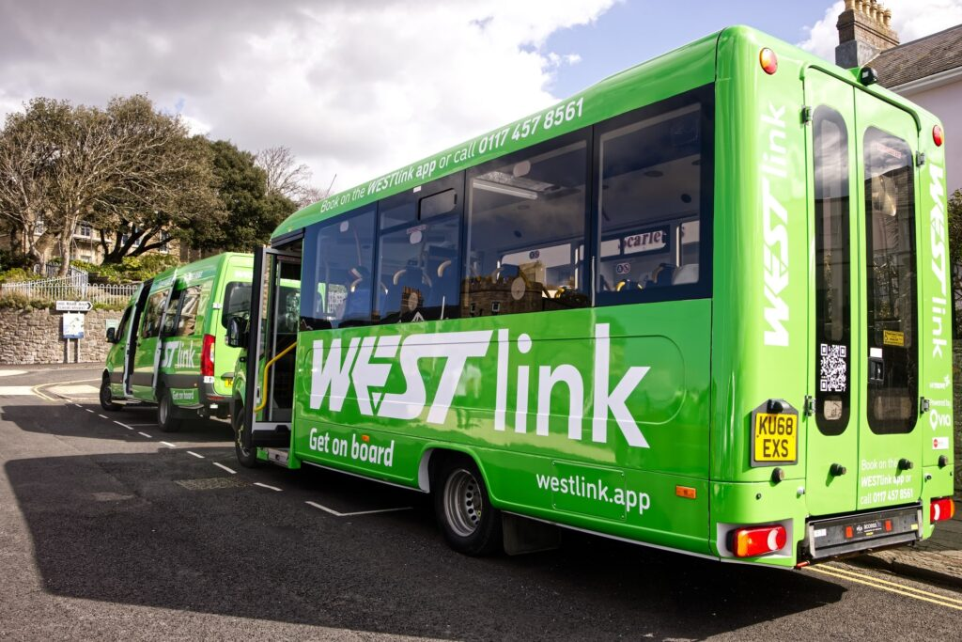WESTLink is a bus service without a set **timetable** or **route**. The bus runs in most of the West of England, outside of Bristol and Bath city centres.

Image credit: Travel West website

Image description: A WESTLink bus parked on the street. The bus is lime green with ‘WEST link’ written across the side in big white letters.

You have to book the bus to tell the driver where you would like to be picked up and dropped off. You can book on the day you want to travel or the day before. There are three ways to book: on the app, on the website and over the phone.

The bus costs £2 for adult single and £1 for a child single (young children that can sit on an adult’s lap are free). You can use your Disabled persons bus pass and older persons bus pass after 9am Monday to Friday and all day on Saturdays.

[Find out more on the WEST Link website](https://travelwest.info/westlink/).

## Try a new way to travel

### Try something new for free

If you would like to try out a new way of getting around the city, Travel West allow you to try different types of transport for free. For example:

* Bus **taster tickets**,
* Train **taster tickets**,
* Portway or Brislington Park & Ride **taster tickets**,
* Borrow a bike for up to four weeks,
* Cycle training.

These offers are subject to **eligibility**, visit the [Travel West website](https://travelwest.info/for-communities/individual-support/) to find out more.

### Cycling

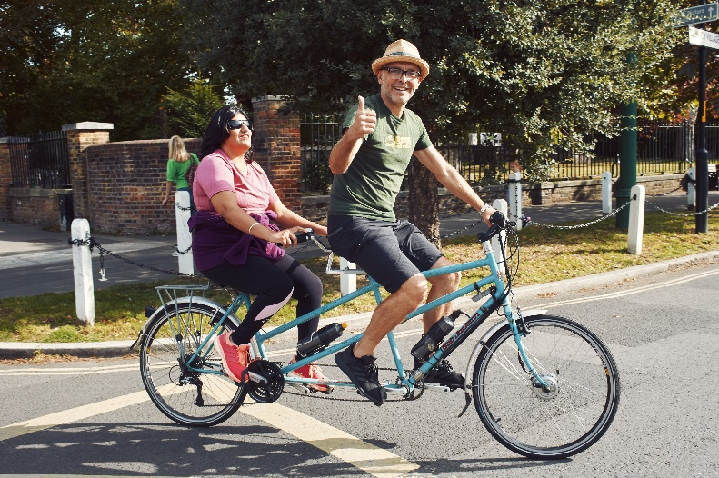[Better By Bike](https://betterbybike.info/) is a website with information about cycling in the West of England. They have lots of information such as a **route planner** and a map where you can find places to buy and rent bikes.

Image credit: Wheels for Wellbeing

Image description: Two people riding a tandem bike in a park. They are both smiling. The man riding at the front is wearing a green t-shirt, a straw hat and is giving a thumbs up to the camera. The woman riding on the back of the tandem is visually impaired, she has long black hair and is wearing a pink t-shirt and dark sunglasses.

[Life cycle](https://www.lifecycle.org.uk/) are a charity who offer cycling activities in Bristol including free adult cycling lessons and **tandem** cycle rides for Disabled people.

## Get help with the cost of your journey

### A close-up of a card AI-generated content may be incorrect.Disabled Persons Railcard

A Disabled Persons Railcard gives you and an adult companion 1/3 off most train fares. [Find out more on the Disabled Person’s Railcard website](https://www.disabledpersons-railcard.co.uk/).

Image credit: National Rail website

Image description: A Disabled Person’s Railcard. The card is green and has symbols representing different impairments.

If you are not **eligible** for a Disabled Persons Railcard, there are other types of Railcard that you may be able to get instead. Take a look on the [Railcard website](https://www.railcard.co.uk/).

### Disabled Person’s Bus Pass

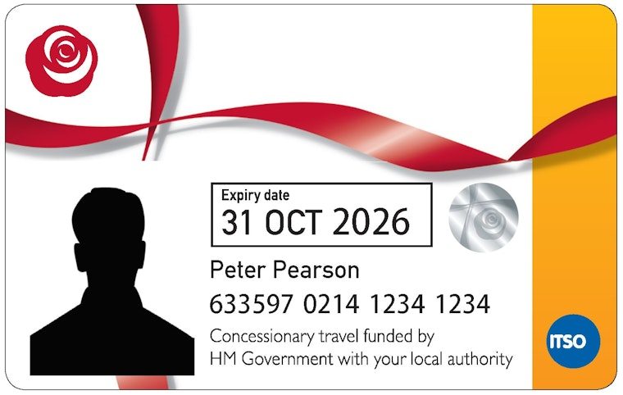A Disabled person’s bus pass allows you to travel for free on off-peak bus services anywhere in England.

Image credit: sanderscoaches.com

Image description: A Disabled person’s bus pass. The card is white with a red rose logo and an orange strip on the right-hand side.

[Find out more about the Disabled person’s bus pass on the Bristol City Council website](https://www.bristol.gov.uk/residents/streets-travel/bus-passes-travelcard/disabled-persons-bus-pass).

In Bristol you can get a Disabled Person’s bus pass if you:

* Live in the Bristol City Council area, and
* You have an **eligible** Disability.

You may also be able to get free travel for the person travelling with you, this is called companion travel, and certain people are **eligible** for it.

Different areas in England allow you to use the Disabled person’s bus pass at different times.

In Bristol, from 6 April 2025 the bus pass can be used 24 hours a day, 7 days a week for journeys starting in Bristol, Bath and North East Somerset, North Somerset or South Gloucestershire. At the moment, this is set to last until 31st March 2026.

If you are blind or partially sighted, you might be able to get a Platinum Travelcard which is a bus pass you can use at anytime on journeys starting and ending in Bristol.

### Older Person’s Bus Pass

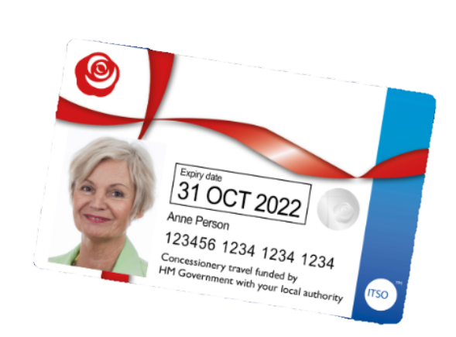In Bristol you can get an older person’s bus pass if you:

* Live in the Bristol City Council area, and
* Are **state pension** age (state pension age is the earliest age you can start getting your state pension).

Image credit: prestonbus.co.uk

Image description: An older person’s bus pass. The card is white with a red rose logo and a blue strip on the right-hand side.

The older person’s bus pass can be used on journeys starting within Bristol, Bath and North East Somerset, North Somerset or South Gloucestershire, Monday to Friday from 9am to 4am the next day and anytime Saturday, Sunday or public holidays

### Birthday Bus Pass

If you are not **eligible** for a Disabled person’s bus pass or an older person’s bus pass, you can get free bus travel during your birthday month until November 2025. Apply online at [birthdaybus.co.uk](https://www.birthdaybus.co.uk/)

## Accessibility on your journey

Image credit: The Boys in Bristol

Image description: Platform 7 at Bristol Temple Meads train station. The track is empty, and the information display reads that the next train due is the 10:22 to Portsmouth Harbour. The multicoloured houses of Hotwells can be seen in the distance.

### Accessible train stations

National Rail have an [online map](https://accessmap.nationalrail.co.uk) which shows the **accessibility features** of train stations across the UK. There is also a [screen reader version](https://accessmap.nationalrail.co.uk/text) which is text only, this allows people using screen readers to hear the accessibility features for all National Rail stations.

The accessibility features it shows includes, whether the station has:

* **Step free access** – the map describes whether this is the whole station or parts of the station, and what kind of step free access, for example lifts or ramps to platforms,
* Staff available who can help,
* **Public toilets** (toilets that can be used by anyone),
* **Changing places toilet** (toilets that have more space and equipment than standard accessible toilets)**,**
* Ramps available for getting on and off the train,
* **Induction loop** (also called a hearing loop, it sends sounds to the person’s hearing aid or cochlear implant).

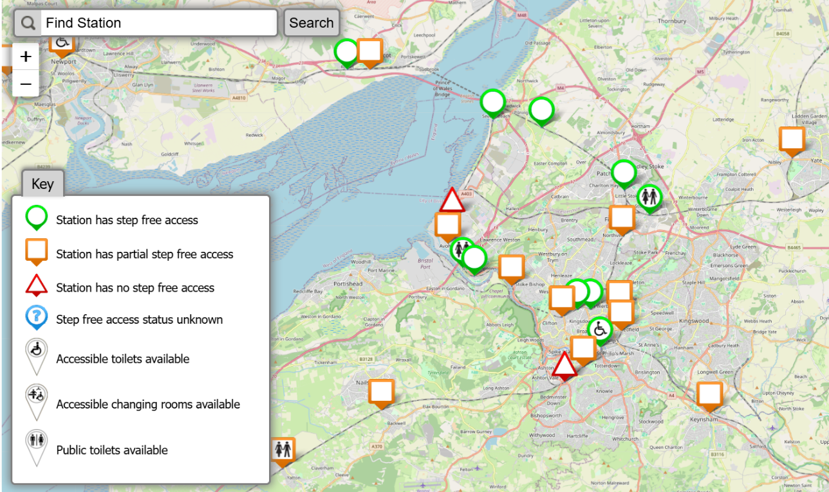

Image credit: National Rail Access Map

Image description: National Rail’s Access Map zoomed in on Bristol but some of the surrounding areas can also be seen, including the Bristol Channel and parts of Wales. Symbols represent the accessibility features of each station, these are explained on the key.

### Passenger assistance when getting the train

There are different ways to request **passenger assistance** when getting the train:

* [Request assistance online](https://booking.passengerassistance.com/?_gl=1%2a7bzpsi%2a_ga%2aMTY4NTU5Mjc0Mi4xNzQwNTAxOTQw%2a_ga_5GT6LE54XS%2aMTc0MDUwMTkzOS4xLjAuMTc0MDUwMTkzOS42MC4wLjA.%2a_ga_3FE41MK7X7%2aMTc0MDUwMTk0MC4xLjAuMTc0MDUwMTk0MC42MC4wLjA.&_ga=2.176782755.743035447.1740501940-1685592742.1740501940)
* Use the **Passenger Assistance** by Transreport app
* Call 0800 022 3720. Select option 1 and let them know the journey you plan to take, and they will connect you to the right train company to place your booking request
* Visit the [Passenger Assistance website](https://passengerassistance.com/) for more information

## Report a problem on your journey

If you can, it is important to report any problems on your journey so they can be fixed and so you can get the support you need. Problems could include: a broken bus shelter, an electronic display not working, an incident on public transport or a blocked pavement.

### Buses

[Report a problem with a bus stop or shelter](https://www.bristol.gov.uk/residents/streets-travel/report-a-street-issue/bus-stops-and-shelter-problems#:~:text=What%20you%20can%20report%20and%20how%20to%20report,we%20can%20find%20it%20and%20fix%20the%20problem.) to Bristol City Council.

Report a problem on a First Bus service [via their online form](https://www.firstbus.co.uk/help-support/complaints-feedback/send-complaint-or-feedback) or by calling them on 0345 646 0707 (phoneline open 9am to 5pm Monday to Friday).

Report a problem on a Stagecoach service via their online form or by calling them on 0345 241 8000 (phoneline open 8am to 6pm Monday to Friday, and 9am to 5pm Saturday and Sunday).

If you have made a complaint to a bus company and you are not happy with the response, the charity Bus Users UK can help. [Visit their website](https://bususers.org/) to find out how they can help.

### Trains

Report a problem on a GWR train [via their online form](https://www.railhelp.co.uk/gwr/make-a-complaint) or by calling them on 03457 000 125 (phoneline open 6am to 11pm).

Report a problem on a Crosscountry train [via their online form](https://www.crosscountrytrains.co.uk/customer-service/contact-us/general-enquiries), by calling them on 03447 369 123 (phoneline open 9am to 5pm Monday to Friday, and 9am to 4pm Saturday), or via [BSL interpreter (video relay service)](https://connect2.interpreterslive.co.uk/vrs?ilc=CrossCountryTrains).

### Taxis

Drivers must let **assistance dogs** in their taxis, unless they have a reason not to and have been allowed not to. If they have been allowed not to, this is called ‘an **exemption**’ and they will have an exemption certificate in the taxi and a yellow card in the taxi’s windscreen.

When you take a taxi, you should not be charged extra if you have an **assistance dog** or if you are a wheelchair user.

If you experience a problem whilst booking or taking a taxi in Bristol, you can [report this through an online form to Bristol City Council](https://www.bristol.gov.uk/residents/streets-travel/taxis/taxi-complaints).

Make sure you write down or take a picture of one of the following numbers, as you will be asked for this when you make a complaint:

* **Taxi’s registration number** (the number plate on the outside of the taxi, at the front and the back)
* **Taxi’s licence number** (displayed inside the taxi and on the plate at the front and back of the taxi)
* **Driver's badge number** (drivers have two badges, they must wear one and display the other on the dashboard inside their taxi)

If you have a problem with a taxi in another area, you will need to report this to the local council in that area. For example, if you experience a problem with a taxi in Yate, you will need to [report this to South Gloucestershire Council](https://beta.southglos.gov.uk/taxis/#how-to-make-a-complaint).

### Hate crime

Hate crime is described as**:** crimes carried out against someone because of their race, religion, sexuality, disability or gender. For example, threatening behaviour such as verbal abuse or rude gestures.

There is information on Bristol City Council website about how to report hate crime to the police, [please follow this link](https://www.bristol.gov.uk/residents/crime-and-emergencies/hate-crime). You can also get free support from [Bristol Hate Crime and Discrimination Services](https://www.bhcds.org.uk/).

### Blocked pavements

Blocked pavements are a problem for Disabled people. For example, they can stop wheelchair users or **mobility aid** users being able to get past.

If a pavement is blocked, for example by large bins or rubbish, and you can’t get past, you can report this to Bristol City Council. [Report an ‘obstruction blocking access’ on Fix My Street](https://fixmystreet.bristol.gov.uk/report/new?longitude=-2.574277&latitude=51.457566).

If a vehicle, such as a car or a van, is parked on the pavement and blocking your way through, then you can report this to the police. Make sure to get an incident reference number so that you can follow it up if needed. For more information on reporting, including how to report not via the phone (for example if you are Deaf or hard of hearing), please see [Contact us | Police.uk](https://www.police.uk/pu/contact-the-police/report-a-crime-incident/)

## Where to find further information and support

We know that the barriers to getting as a Disabled person, and having to fight for your access, is very tiring and frustrating. The below organisations offer help, advice and support.

* [Transport for All](https://www.transportforall.org.uk/) Helpline – if you need advice about accessible transport.
  + Freephone: 0800 368 6102 (then press 1)
  + Email: [contactus@transportforall.org.uk](mailto:contactus@transportforall.org.uk)
  + Open: 10am-5pm Monday, Tuesday and Friday
* [Samaritans](https://www.samaritans.org/) – if you need someone to talk to who will listen and not judge.
  + Freephone: 116 123
  + Open: 24/7

There are a number of individuals and organisations working hard to make transport more accessible for Disabled people in Bristol, and across the UK. Below are a number of organisations where this is their main focus, or it is part of what they do. This is not a complete list (there will be organisations not listed below).

### National organisations

[Transport for All](https://www.transportforall.org.uk/) – accessible transport for Disabled people nationally

[National Centre for Accessible Transport](https://www.ncat.uk/) - accessible transport for Disabled people nationally

[Wheels for Wellbeing](https://wheelsforwellbeing.org.uk/) – inclusive cycling for Disabled people nationally

### Local organisations

[Brandon Trust](https://www.brandontrust.org/)

[Bristol Disability Equality Forum (BDEF)](https://bristoldef.org.uk/)

[Bristol Older People’s Forum](https://bopf.org.uk/)

[Stand Against Racism and Inequality (SARI)](https://saricharity.org.uk/)

[West of England Shared Transport and Active Travel Network (WESTACT)](https://westact.org/)

[West of England Centre for Inclusive Living (WECIL)](https://wecil.org.uk/)

[West of England Sight Loss Council](https://www.sightlosscouncils.org.uk/meet-the-councils/west-of-england/)

[Centre for Deaf and Hard of Hearing People (CfD)](https://cfd.org.uk/)

## Jargon buster

**Accessible:** When a Disabled person can use or take part in something because their needs have been met.

**Accessibility features:** The things that allow a Disabled person to use or take part in something because their needs have been met. For example, a ramp would allow a wheelchair user to get in to a building.

**Active travel:** Making journeys in physically active ways, like walking, wheeling (using a wheelchair) and cycling.

**Assistance:** Help with something.

**Assistance dog:** A dog that has been trained to support a Disabled person or a person with a medical condition. For example, guide dogs and hearing dogs.

**Car club:** An organised system for people to share cars.

**Changing places toilet:** These are toilets which have more space and equipment than standard accessible toilets.

**Electric car charging point:** This is a place where an electric car’s battery can be charged.

**Eligible (eligibility):** Whether or not you can have or do something based on a list of rules. For example, to get a Disabled person’s bus card you have to have one of a list of disabilities.

**Incident reference number:** This is a number you will be given by the police which

**Induction loop:** Also called a hearing loop, it sends sounds to the person’s hearing aid or cochlear implant. For example, at a train station ticket office, a hearing aid user can connect to the induction loop which will send the sound of the staff member, who is speaking into a microphone, to their hearing aids.

**Jargon buster**: A list that explains the words that not everyone will understand.

**Journey planner:** A website or app that gives directions for getting from one place to another. This is sometimes called a route planner.

**Mobility aid:** A device that helps a person get around more easily, for example a wheelchair, a walking stick, a walking frame or a mobility scooter.

**Passenger assistance:** The help given to Disabled passengers who are getting a train, plane or other types of transport. The type of help given will depend on the person. It could include help carrying bags, being guided around the station or a ramp to get onto the train.

**Public toilet:** A toilet that can be used by anyone.

**Public transport:** Vehicles that anyone can use which travel from one place to another. Examples of public transport include buses, trains, taxis and trams.

**Published:** Making something available to the public by printing it out on paper or putting it on a website.

**Retirement:** Retirement is when you leave your job and stop working. People usually retire when they reach retirement age, or due to poor health. People can also retire early, if they have enough money to live on.

**Route:** Going from one place to another, for example from Brislington to Bristol Bus Station.

**Route planner:** A website or app that gives directions for getting from one place to another. This is sometimes called a journey planner.

**State pension:** A pension is money to live on when you reach State Pension age. It is paid to people by the government. At State Pension age you can continue to work, or you can choose **retirement**. Whichever you choose, you can get your State Pension.

**Step free access:** the map describes whether this is the whole station or parts of the station, and what kind of step free access, for example lifts or ramps to platforms,

**Sustainable:** Transport that has a low impact on the environment, including active travel and **public transport**.

**Taster ticket:** Where you get a free ticket to try something for a set amount of time, for example a free bus ticket for a day or a week.

**Tandem:** A bike which has seats for two or more people.

**Taxi drivers badge number**: Taxi drivers have two badges, they must wear one and display the other on the dashboard inside their taxi.

**Taxi’s licence number**: This number is displayed inside the taxi and on the plate at the front and back of the taxi.

**Taxi’s registration number**: The number plate on the outside of the taxi, at the front and the back)

**Timetable:** For a bus or a train, the timetable says when the bus or train will leave and what time it will arrive at each stop.

**Vision:** When you think about how things could be better in the future so that you can work out what changes need to be made.

This guide was developed as part of the Community Climate Action Project, coordinated by Bristol Climate & Nature Partnership, and funded by the National Lottery’s Climate Action Fund. It was written by Florence Grieve, Inclusive Transport Advocate, with input from Sustrans and Bristol Climate & Nature Partnership colleagues.





FUNDED BY